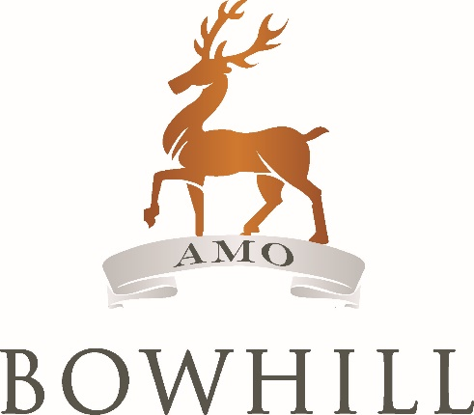

**Access Guide for**

**Bowhill House & Country Estate**

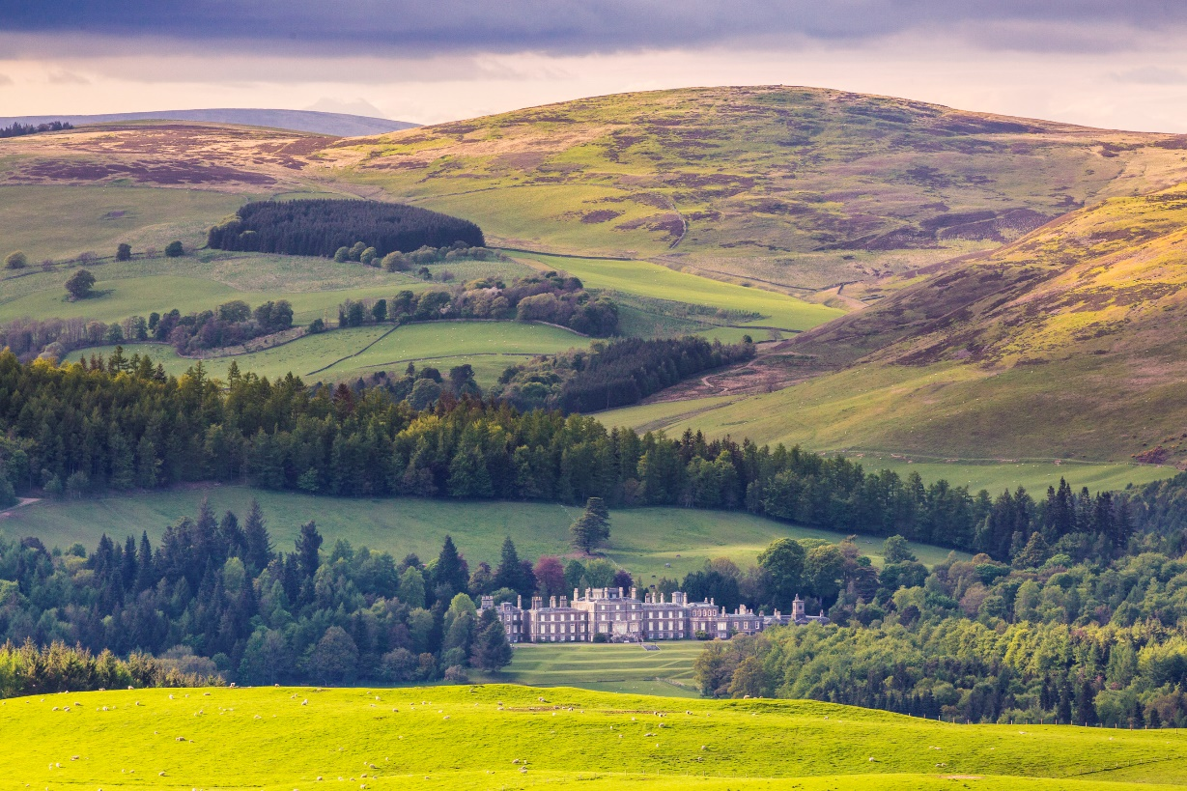

­This access statement does not contain personal opinions as to our suitability for those with disabilities, but aims to accurately describe the facilities and services we offer for all our visitors.

**Contents Page**

Introduction 3

* Carers Entry 3
* Assistance Dogs 4

Pre-arrival 4

Arrival 5

Car parking 8

Main entrance, Reception, Gift Shop 9

Attractions 11

The Courtyard 11

Victorian Kitchen 12

Exhibition 13

Bowhill House 14

Bowhill Theatre 16

Soft Play 17

Adventure Playground 17

Gardens 18

Walks 19

Tearoom 21

Toilets 22

Feedback 22

Contact Details 23

**Introduction**

Bowhill House and Country Estate lies three miles west of Selkirk on the A708 Moffat/St Mary’s Loch Road. Selkirk is five miles south of Galashiels on the A7 from Edinburgh. Bowhill sits between the Ettrick and Yarrow Valleys, surrounded by beautiful winding glens and heathery hills.

Bowhill House, which is still the Scottish Borders home of the Duke of Buccleuch, is open on selected dates from Easter to end September. Groups can visit year round by appointment.

Bowhill is also an educational resource for scholars of all ages, and there is a small 72 seat theatre converted from the old Victorian game larder, which programmes a range of shows throughout the year.

The Estate is open from Easter to end September (please check [our](http://www.bowhillhouse.co.uk) [opening times](http://www.bowhillhouse.co.uk/plan-a-visit/opening-times/) for details). There are a range of activities and attractions within the Estate including gardens, an Adventure Playground, waymarked walking routes, a Tearoom selling home-made goodies, Soft Play and Gift Shop specialising in local products. Bowhill provides a wonderful day out for all the family and has special events on most weeks during the open season from Ranger activities to guided walks and Land Rover tours.

Bowhill House & Country Estate is a member of the VisitScotland quality assurance scheme with a five star rating. There is one wheelchair available for use, which you can request when you book your tour in the Gift Shop or in advance by calling 01750 22204. There is a hearing loop system in Bowhill Theatre. Unfortunately the Gift Shop and House does not have a hearing loop.

Carers

Our admission policy admits the necessary companion or carer of a visitor with access requirements free of charge, while the normal admission fee applies to the visitor.

Assistance Dogs

Assistance dogs are very welcome everywhere. We also welcome other dogs and have water bowls and extra dog waste bags in the Courtyard. We ask that dogs are kept on a lead, cleaned up after and remain in the ‘dog friendly’ edges of the play park, not the middle of it.

It is important to note that the mobile phone reception and 3G can be patchy due to our countryside location. If your call is urgent, we are happy for visitors to use our landline. Please ask in the Gift Shop.

**Pre-arrival**

For directions from anywhere in the world to Bowhill, have a look at [Red Planet Travel](http://redplanet.travel/). On arrival at Bowhill when you come off the A708 be sure to take the right fork signed Bowhill House and Theatre, not the left fork to the Estate Office.

**By car**

* Bowhill lies three miles west of Selkirk on the A708 Moffat/St Mary’s Loch Road. Brown tourist signs mark the route.
* For full details and maps of how to reach us, please see the [Find Us](http://www.bowhillhouse.co.uk/contact-us/find-us/) section of our website.
* Our postcode for SatNav is TD7 5ET.

**By public transport**

* **Train:** the closest stop on the Borders Railway is Galashiels, it also has the best transport links. Exit the train at the Galashiels Station. From here, Bowhill is just five miles away via the A7 (15 minutes by car). You can **cycle** in 45 minutes to an hour, or get a taxi from here.
* **Buses:** unfortunately there are no regular buses to Bowhill. However you can find out more information on buses to Selkirk and Galashiels at [www.traveline.info](http://www.traveline.info).

**Local taxis**

* Hunters Cabs:  01750 721968
* Selkirk Taxis (wheelchair accessible vehicles available): 01750 234567
* 5 star Taxis (wheelchair accessible vehicles available): 01896 756789

If you’d like us to call a taxi for you, please ask in the Gift Shop.

**Arrival and car parking**

**Arrival**

**Rough layout of Bowhill:**



* On arrival, a member of staff will meet you at the entry kiosk on the main drive to Bowhill (please follow green signs). Here they will come to your car window to welcome you, take your entrance fee and explain any events on that day and orientation.
* This member of staff is more than happy to help if you have any questions and also has a two-way radio so can contact a member of staff at the main attraction or car park to meet you if necessary.
* Payment can be made by cash or credit/debit card.

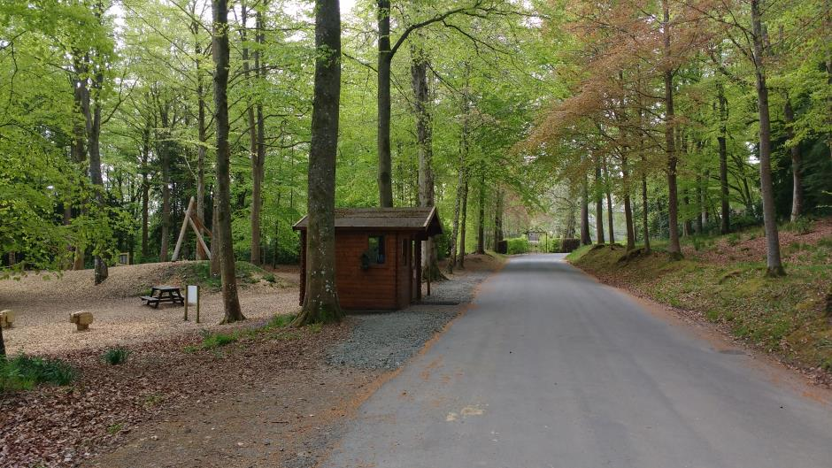

Entrance kiosk on the main drive in to Bowhill

* When the entry kiosk is not manned, please follow signs to the main car park or accessible car park and make your way to the Gift Shop located in the main Courtyard area (signposted).
* If required, cars can pull off the drive outside the main Courtyard to drop people off to reduce the walk. Please drive with caution as there will be visitors in this area.
* Please note the drive is used by multiple users including cars, pedestrians, horses, bicycles, estate vehicle and others. As such speed bumps are located along it.

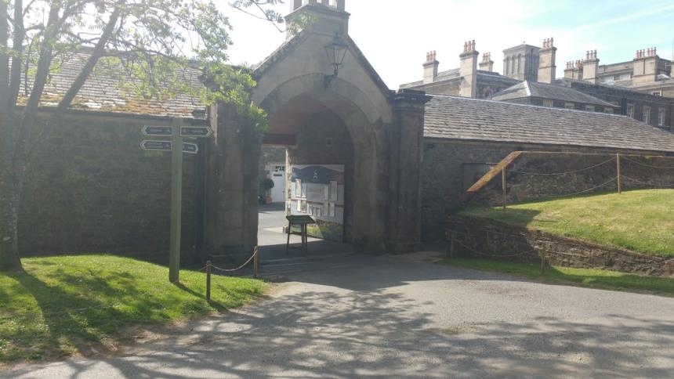

Cars can pull into Courtyard entrance (not past the archway due to safety) to drop pedestrians off

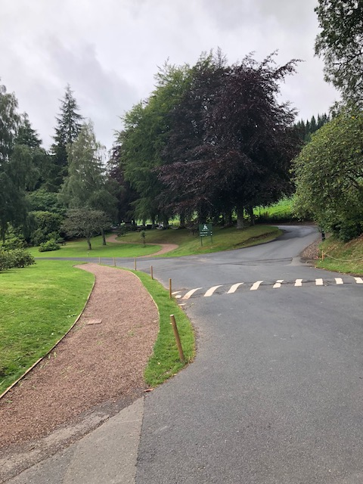

Speed bumps along the main drive

**Car parking**

* Parking is available free of charge at Bowhill.
* The main roads at Bowhill are tarmac. However, the surface in the main public car park is uneven with loose stones.
* The surface of the accessible car park (at the entrance to Bowhill House) is tarmac with loose gravel in some areas. Please note that some staff and also the Duke, Duchess and their family also use this car park.
* There is automatic lighting activated by sensor to this area when it is dark.

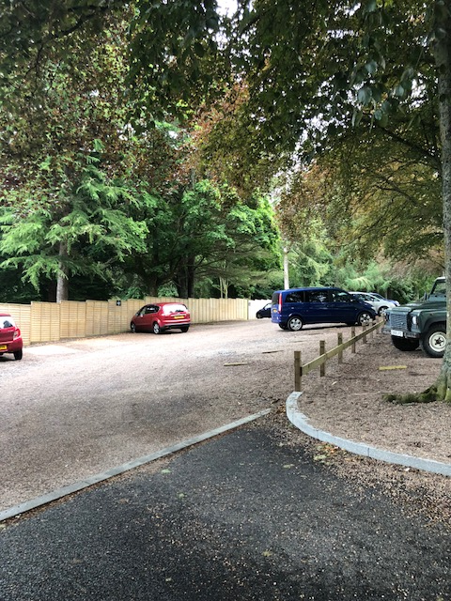

Main car park (shortest distance from Courtyard is approximately 102 metres)

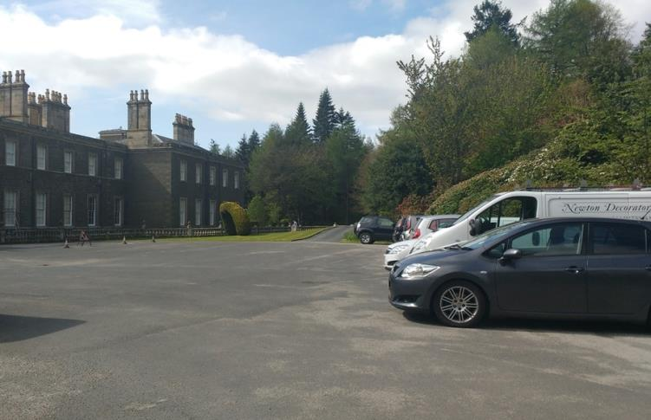

Accessible car park (shortest distance from Courtyard is approximately 90 metres)

* The main Courtyard area which has accessible toilets, Gift Shop, Tearoom, Soft Play, Bowhill Theatre and Victorian Kitchen is a mixture of tarmac, even stone paths and cobbles.
* There is a new gravel path from the car park to adventure playground which avoids the road as much as possible.
* All waymarked walks are informal country paths and as such can be uneven, muddy and have tree roots.

**Main Entrance, Reception, Gift Shop**

* We recommend that visitors start their visit in the Gift Shop/Reception. Here a member of staff is on hand to answer queries and book visitors on to House tours and other activities.
* The Gift Shop is located in the courtyard area and is the second door on the left, accessed by a small ramp to narrow double doors. These doors should both be unlocked and measure 900mm when open.
* Inside the floor is even and most wheelchairs and buggies should have ample room to move around displays.
* We stock a wide range of locally produced goods and pocket money toys for children.
* A member of staff will always be happy to help with objects on higher or lower shelves.

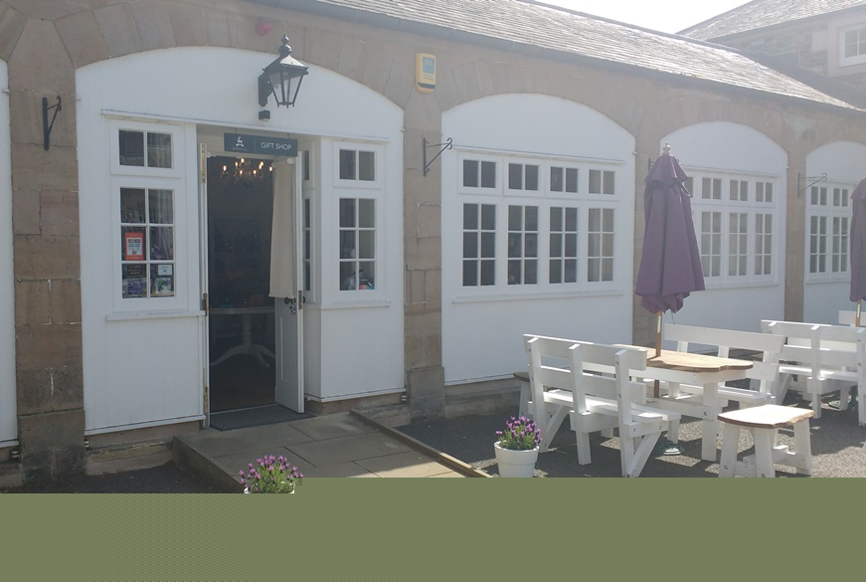

Gift Shop entrance

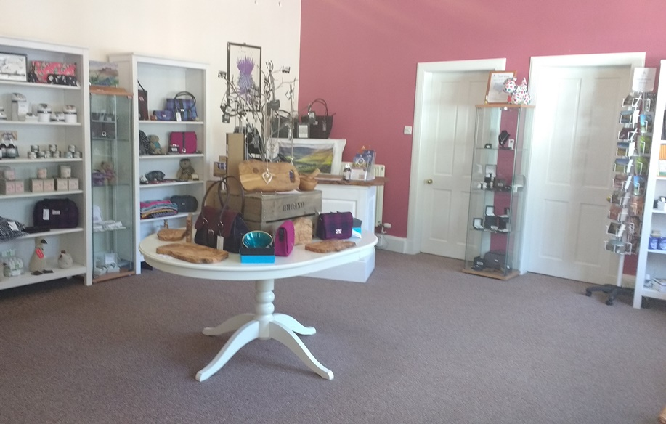

Gift Shop interior

* This is also where you book your House tour. Please let the members of staff know if you would like to borrow a wheelchair, a stool seat or have any access needs.
* House tours meet at the front door of the House, so there is a five minute walk on tarmac and gravel with a slight incline from the Gift Shop.

**Attractions**

**The Courtyard**

* The Courtyard is the main hub and location for most visitor facilities. The Courtyard is surfaced in mostly tarmac, with some traditional cobbles and stone paths around the cobbles.
* The Courtyard has a selection of picnic benches, outdoor games (dominoes and/or giant draughts or chess) and planters. Benches have space for wheelchairs and several have umbrellas for shelter from the sun.
* There are water bowls for dogs, an area to tie dogs up, and dog waste bags available.
* A bike rack is available.
* Please note there is no vehicle access to the Courtyard area during public opening times except in extreme circumstances. This is due to safety considerations.

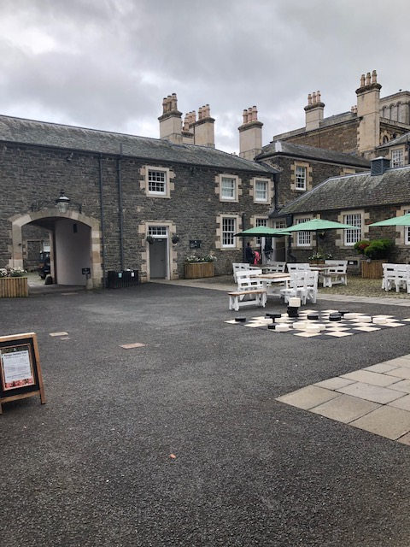

Courtyard

**Victorian Kitchen**

* Accessed from the Courtyard up a ramp and through two doors (smallest width 820mm).

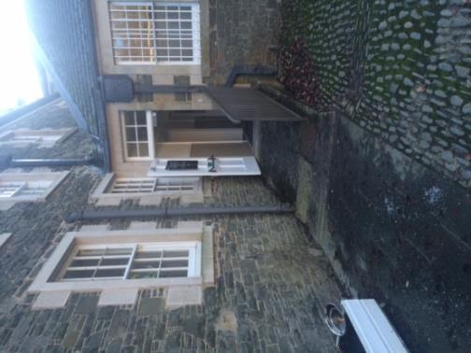 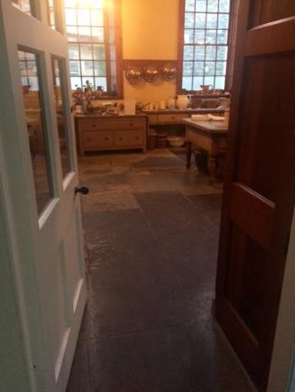

Access from Courtyard The Victorian Kitchen entrance

* The traditional stone floor is slightly uneven.
* The Victorian Kitchen has a Guide in it most weekends and in July and August. (Please ask in shop for times) There are also some written materials to view.

**Exhibition – Love and Respect in the Victorian Age.**

* The exhibition is accessed from the rear of the Victorian Kitchen, through two doors. The narrowest width is 790mm.
* The floor is even and there is room for wheelchairs to manoeuvre round the exhibits. Most exhibits are visible from wheelchair height and there is a large print guide available.
* The exhibition is open on certain days – please check website or call us on 01750 22204 for details.

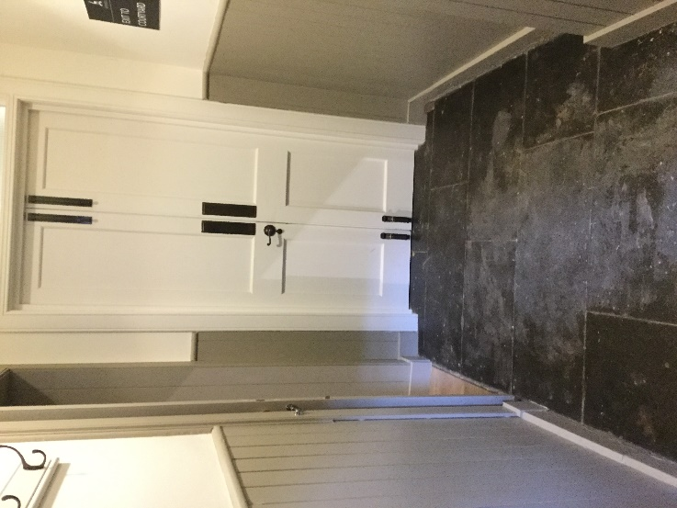 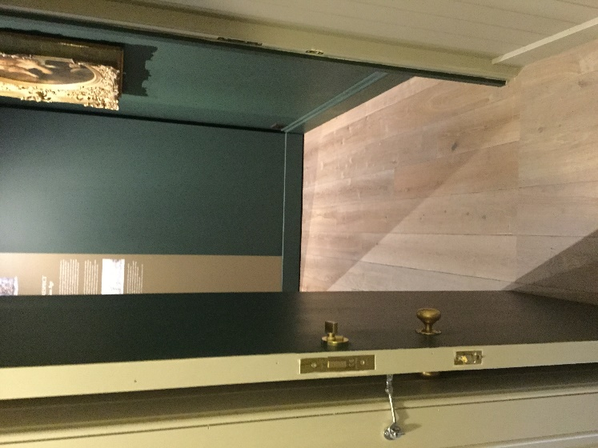

Entry from Victorian Kitchen Next door entrance into exhibition

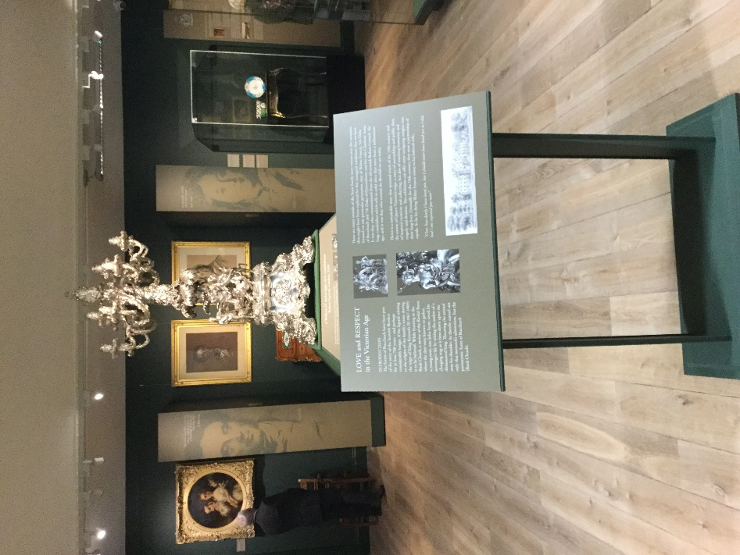

Exhibition

**Bowhill House**

* Bowhill House is accessible via a guided tour on select [opening dates](http://www.bowhillhouse.co.uk/plan-a-visit/opening-times/). Groups can book year round by [appointment](http://www.bowhillhouse.co.uk/plan-a-visit/group-visits/).
* Please don’t hesitate to discuss any access needs with your guide, the member of staff in the Gift Shop or in advance by calling 01750 22204 or emailing/writing to us.
* The narrowest door width within the House is 900mm.
* The ‘Beautiful Bowhill’ tour is on one level with the exception of one room, the Old Chapel which is accessed by 4 steps with a hand rail.

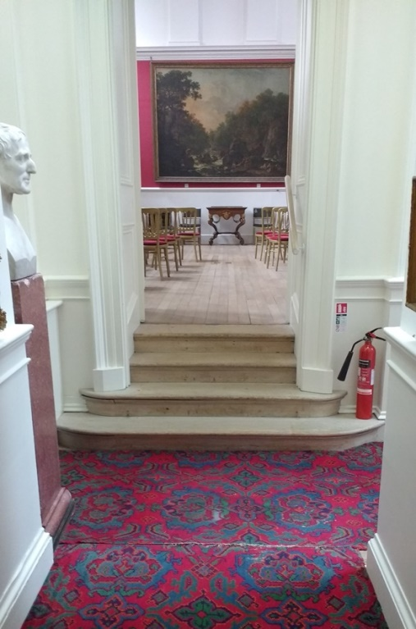 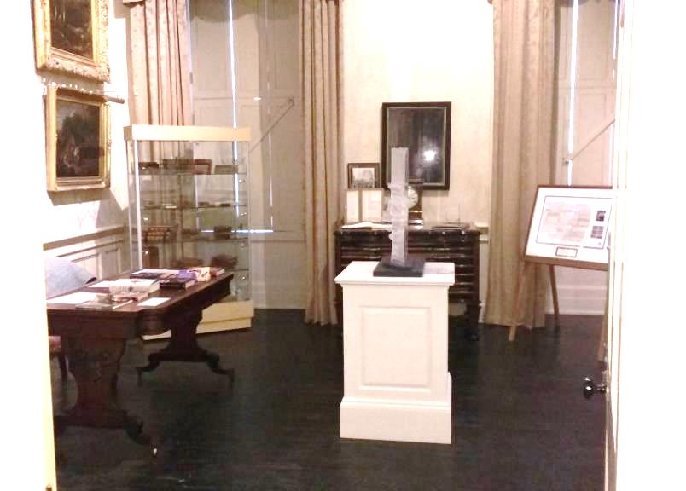

Steps to ‘Old Chapel’ Limited room around the Scott Room

* The Beautiful Bowhill Tour takes approximately 1 hour and 15 mins.
* The Boudoir and Bedrooms tour, which runs twice per day when the house is open, may not be suitable for those with mobility difficulties due to the stairs. It takes approximately 45 minutes.
* Please note that portable lightweight stools are available for the duration of the tour and the gold chairs with red seats located throughout the House can be sat on. Please ask your guide for assistance if required.
* Please note that there are no public toilet facilities located within the House.
* Duke John, 9th Duke of Buccleuch, used a wheelchair so the House is generally suitable for wheelchairs. However, due to the historic nature of the building and the vulnerability of the collections, the House is unfortunately not suitable for large, motorised, motability scooters. Please phone us for assistance if you have one of these.
* The flooring in the House is a mix of carpet, wooden floors and stone floors.
* Lighting is generally good.
* The heating is often not on in order to protect the fabric of the building and the collection, so it can sometimes be cold.
* We have short, basic, language guides to the tour in French, German, Italian and Spanish and also large print information about the rooms which will be found on the public tour.
* There is very little written interpretation in the House, but a beautifully illustrated Guidebook, written by the Duke of Buccleuch, is available for sale in the Gift Shop.

**Bowhill Theatre**

* Accessed from the Courtyard up a ramp and then straight on through a door and then right and through a door.
* The traditional stone floor is slightly uneven. The Theatre itself has thin carpet.
* There is seating available on floor level or there are steps up to more seating (with a hand rail).
* Lighting is quite dim within the Theatre.
* A hearing loop system is in operation.

 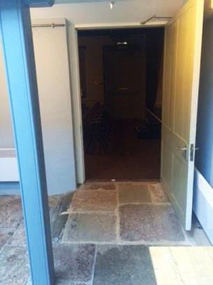 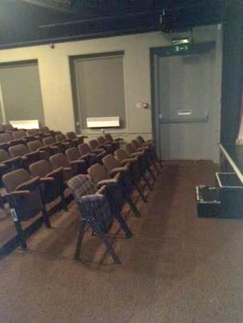

Access from Courtyard Entrance to Theatre Inside Theatre

**Soft Play**

* The Soft Play is accessed from the Courtyard, through a gate and down a gradual ramp.
* The Soft Play door is usually kept shut to keep the warmth in and to allow children to move around freely inside. Inside there is a small seating area for parents/guardians with tables and chairs.
* Non-slip flooring has been installed, and the fall zone around the Soft Play is fitted with soft foam matting.
* The area is heated on cold days and there is a ventilation system in case of very warm weather.

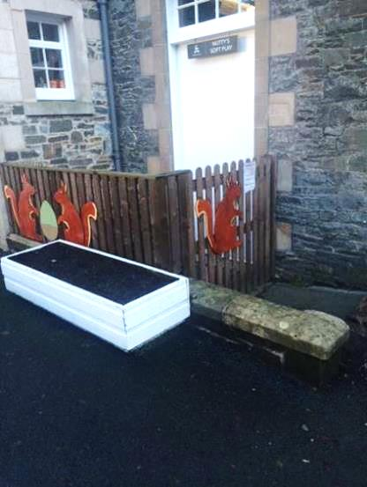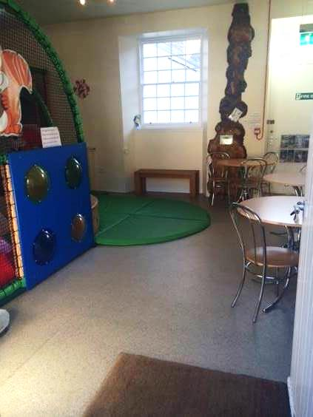

Access from Courtyard Soft Play entry and seating

**Adventure Playground**

* The Adventure Playground at Bowhill has a range of play equipment for different ages and abilities, including slides and climbing equipment. There is a Spider/Bucket Swing and also musical equipment, suitable for all.
* The ground covering in the playground is woodchip.

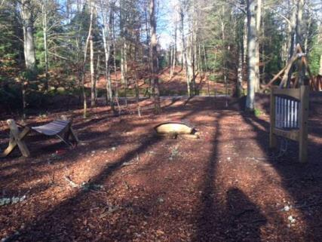 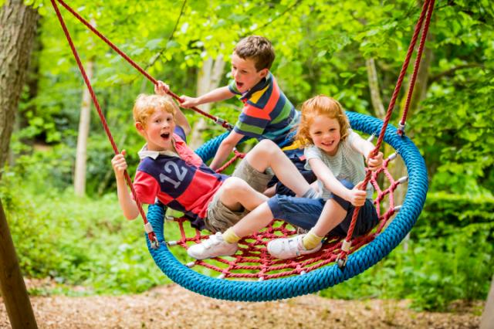

Giant xylophone, turtle drum Spider swing

and musical chimes

**Gardens**

* The Gardens/front of the House can be accessed from either side of the House.
* Access from the Courtyard end is along a gravel path, up a gentle slope and through a gate. After the gate and a short gravel path are a set of stone stairs.

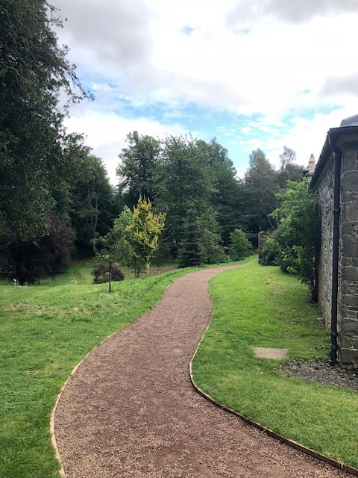 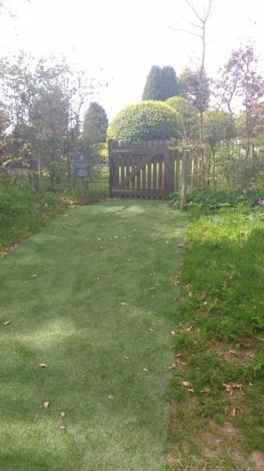 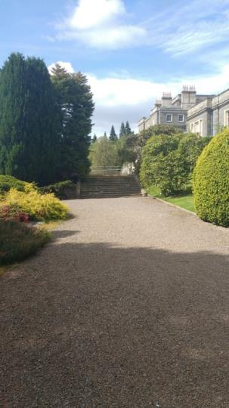

Gravel path Slope to path

Gravel path leading to stone stairs

* The other access route is through the accessible car park, along a gravel path, down a gentle slope and left though a gate into the front of the House/Gardens. This path goes from loose gravel to being quite pebbly.
* Immediately in front of the House the ground is level, with a few benches available for seating. The gardens descend in a series of terraces towards the loch.

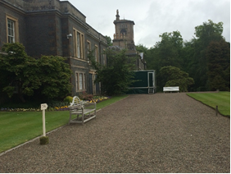

Path in front of Bowhill House

**Walks**

* Bowhill has 4 waymarked walks of varying lengths and difficulties. You can read more about each of these on the [Walking and Hiking Routes](http://www.bowhillhouse.co.uk/outdoor-activities/walking-and-hiking-routes/) section of our website.
* The first half of the Loch’s walk around the top/upper loch is suitable for pushchairs, but has uneven parts with tree roots, muddy areas, etc.

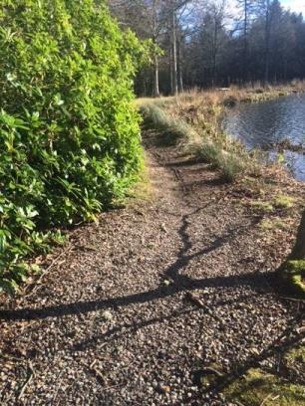 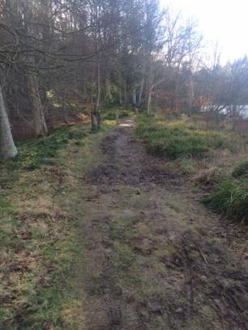 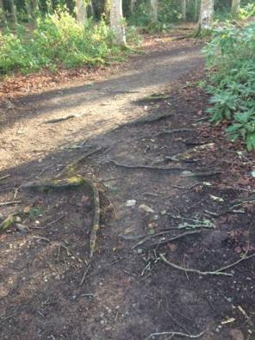

* Nearly half of the walk is on a tarmacked estate road with beautiful views of the Loch and House. It does have a long steep hill on the return (which you go down to start the walk).
* A walks leaflet is available in the Gift Shop. This will give more details about what you can expect to find on each walk.
* There are a few benches for seating and some picnic benches along the walks.

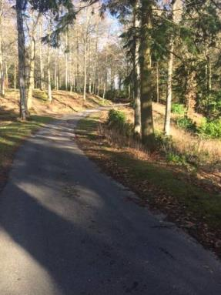

Almost half of the top loch path is on tarmac. It has a steep long hill on the return.

**Tearoom**

The Tearoom, accessed from the Courtyard, has a small step at the entrance.

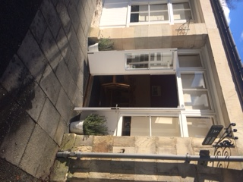 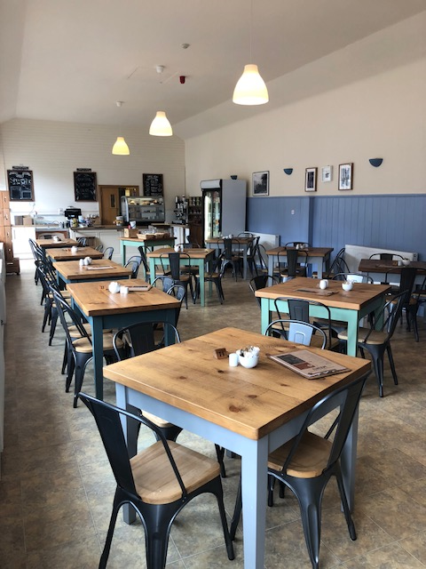

Entrance to Tearoom with small step Tearoom interior

* The Tearoom is counter service, but please don’t hesitate to ask a member of staff if you need assistance. Menus are located on the inside tables, window and on the wall.
* The menu consists of light lunches, hot and cold drinks and home baking. There is also a children’s menu. You can find a copy on the [Food and Drink page](http://www.bowhillhouse.co.uk/wp-content/uploads/2015/03/Bowhill-Tearoom-Menu-2015-FINAL_A4.pdf) of our website.
* Hot water can be provided to heat bottles or a bottle warmer is available to borrow.
* Please ask for any allergy advice. There are gluten free options available (gluten free bread, wheat free oatcakes and pre-packaged cookies/cakes).
* Unfortunately we cannot provide a nut free zone for nut allergies.
* High chairs are available in the Tearoom and all tables and chairs are free standing and as such can be moved easily.

**Toilets**

* Our toilets are located in the main Courtyard area. The gents toilet and the accessible toilet is accessed on the ground level. The accessible toilet also has baby changing facilities.
* There are some steps up to the ladies and other baby changing facility.
* The toilets are fitted with non-slip flooring.

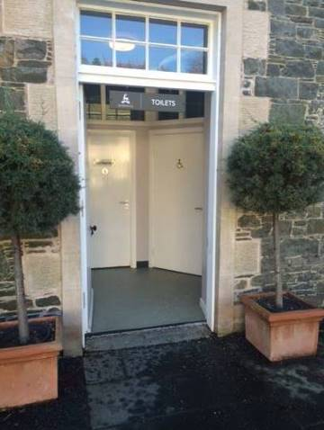 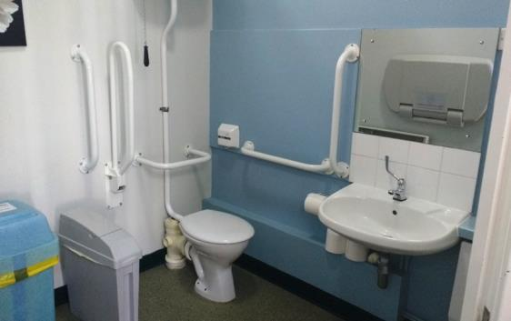  
Toilet entrance from Courtyard Interior of accessible toilet

**Feedback**

If you would like to provide us with any feedback on this Access Statement, we would welcome your comments. We would be interested to hear if there is any information we may have missed that may be of use. We would also welcome feedback on [Euan’s Guide](https://www.euansguide.com/venues/bowhill-house-country-estate-selkirk-77742010).

Please email us on [info@bowhillhouse.co.uk](mailto:info@bowhillhouse.co.uk) or telephone 01750 22204. Alternatively, you can write to us at Bowhill Visitor Service, Bowhill, Selkirk TD7 5ET or speak to us during your visit.

**Contact Details**

Bowhill House and Country Estate

Bowhill

Selkirk

Scottish Borders

TD7 5ET

Tel: 01750 22204

Email: [info@bowhillhouse.co.uk](mailto:info@bowhillhouse.co.uk)

[www.bowhillhouse.co.uk](http://www.bowhillhouse.co.uk)

[](https://www.google.co.uk/url?sa=i&rct=j&q=&esrc=s&source=images&cd=&cad=rja&uact=8&ved=2ahUKEwiQrJ_D7ezcAhWIC8AKHXYKBTsQjRx6BAgBEAU&url=https://www.creativefreedom.co.uk/icon-designers-blog/twitter-logo-history/&psig=AOvVaw0ia2d0KRjiJUggxHxo5s9E&ust=1534346832910622)